Test Plan (OrangeHRM)

Contents

Objective : 1

Scope: 1

Roles and Responsibilities: 1

Schedule and Milestones: 1

Tools and Equipment: 2

1.0 Home Page : 2

1.1 My Info : 3

1.1.1 Personal Details 3

Personal Details 4

1.1.2 Photograph 4

1.1.3 Contact Details 5

Country: Choose from the dropdown menu 5

1.1.4 Emergency Contact 6

1.1.5 Dependents 8

1.1.6 Immigration 10

1.1.7 Job 12

1.1.8 Salary 14

1.1.9 Report To 15

# Objective :

This document serves as a comprehensive test plan for the ESS User module within the OrangeHRM Web Portal. The primary goal is to elucidate the utilization of OrangeHRM by ESS Users and delineate the anticipated outcomes associated with their interactions. By delving into the graphical user interface (GUI) of OrangeHRM, this document aims to provide readers with a nuanced understanding of its features, some of which may not be immediately apparent. In addition to facilitating a comprehension of OrangeHRM from the perspective of ESS Users, this document is instrumental in the creation of test cases and in-depth exploration of various functionalities within the OrangeHRM system.

# Scope:

This assessment will encompass an exhaustive examination of the ESS User features and functionalities embedded within OrangeHRM, including modules such as My Info, Photograph, Contact Details, Emergency Contacts, Dependents, Immigration, Job, Salary, Report To, Qualifications, and Membership. The testing methodology employed will span manual testing, functional testing, and sanity testing.

To ensure the comprehensive validation of the ESS User dashboard and OrangeHRM functionalities across diverse environments, our testing approach will incorporate the utilization of varied browsers, devices, and operating systems.

### Roles and Responsibilities:

Clear delineation of roles and responsibilities is paramount for effective testing. The team composition will encompass roles such as the Test Lead, Testers, and Developers, each assigned specific tasks and accountabilities to streamline the testing process.

### Schedule and Milestones:

A well-defined schedule and milestones have been established for the testing phase. This includes commencement and conclusion dates, as well as a detailed plan outlining key testing activities. Adhering to this timeline will enable a systematic and timely execution of the testing process.

### Tools and Equipment:

The testing toolkit comprises a selection of tools and equipment essential for a comprehensive evaluation. This encompasses testing software, hardware, and documentation templates, ensuring a robust testing infrastructure that aligns with industry best practices.

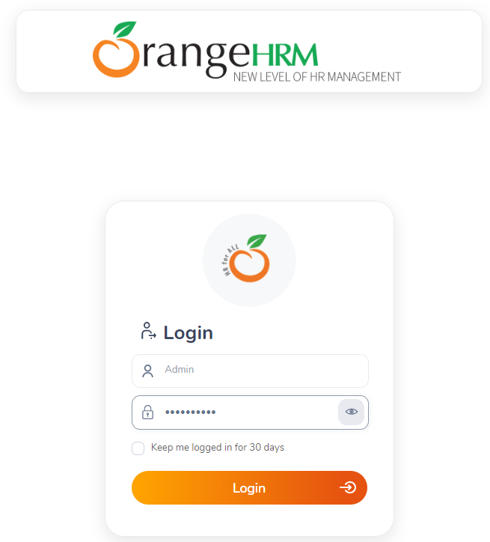

# 1.0 Home Page :

The employee management tool's homepage features tabs including Quick Access, Buzz Latest Posts, My Actions, Latest Documents, Latest News, and Employees on Leave Today as shown in Figure 1.0

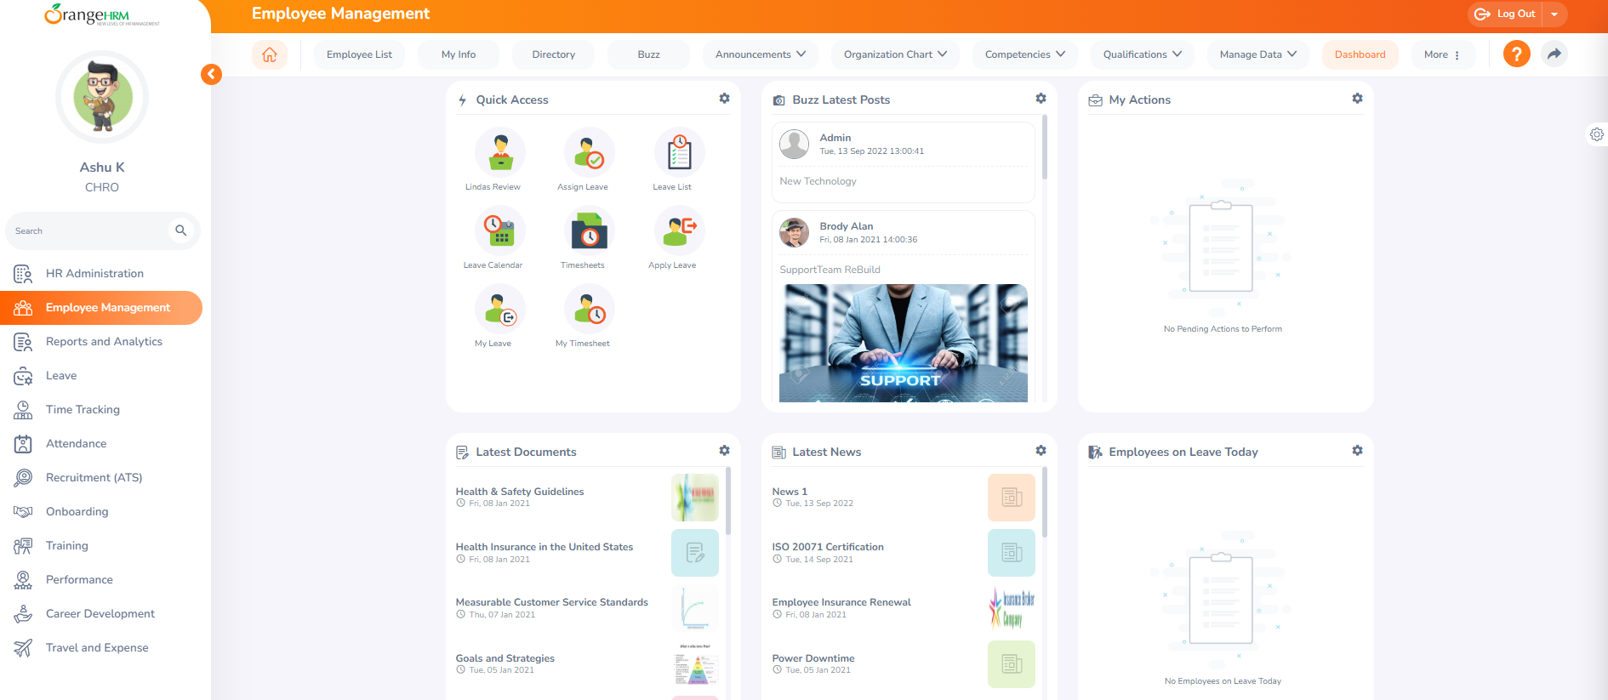

Figure 1.0

# 1.1 My Info :

The My Info Tab empowers employees to access and update personal information independently via an internet-enabled PC, ensuring data security and confidentiality. This functionality spans the entire system, adhering to the company's defined security policy, granting users authorization to view and edit specific fields in the ESS Module. (Figure 1.1)

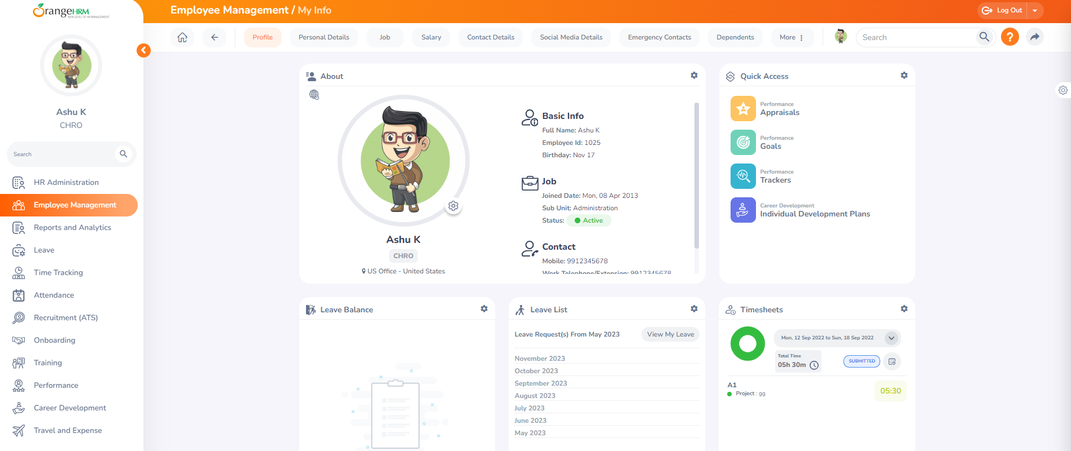

Figure 1.1

# 1.1.1 Personal Details

Upon the initial login of an ESS-User, the first screen presented is the "Personal Details" screen, as illustrated in Figure 1.1.1 Users have the capability to edit and input specific fields. Also the subsequent fields are restricted, and ESS-Users are unable to modify the following details. These must be filled in by the HR Admin and the respective ESS-Supervisor:

### Personal Details

* Employee ID
* SSN No
* SIN No
* Driver License No
* Date of Birth

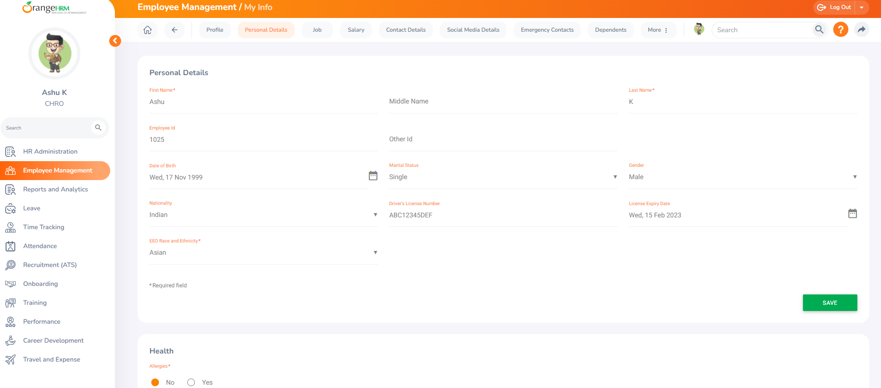

Figure 1.1.1

# 1.1.2 Photograph

The ESS-User can upload a photograph by clicking on the settings icon in the corner of the profile photo screen, initiating the appearance of the screen depicted in Figure 1.1.2.

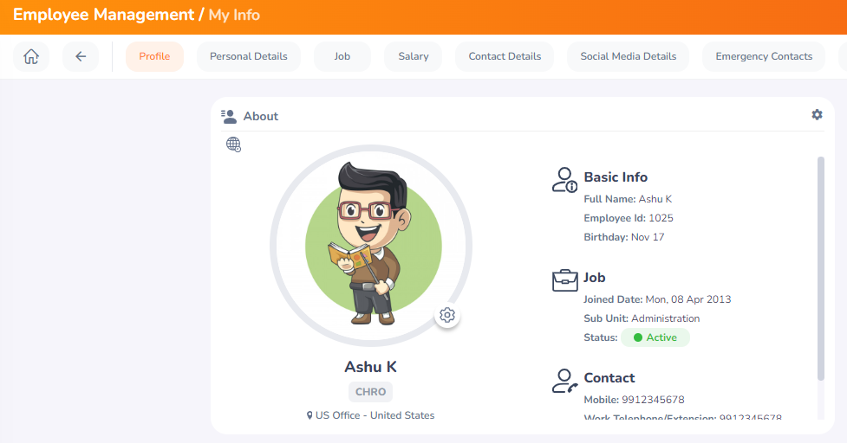

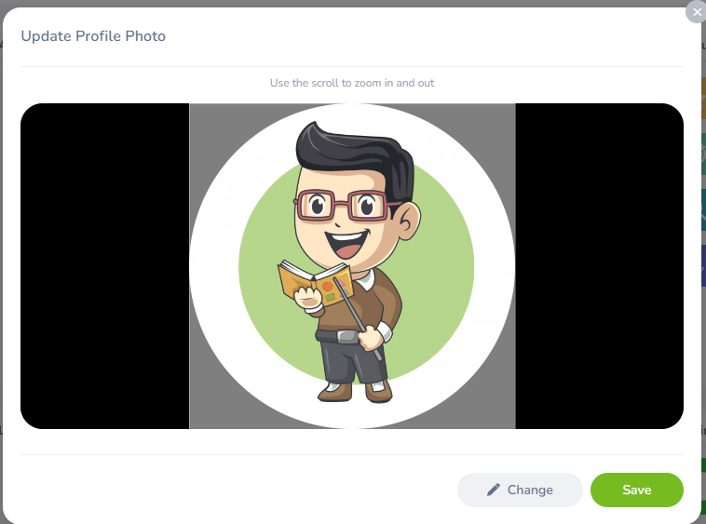

Figure 1.1.2

Click on "Change" to choose a photograph from the designated path. After selecting the picture, click "Open/Upload." The chosen picture will be displayed in the photograph section. *Note: The upload size is limited to a maximum of 1 Megabyte in jpg, png, or gif format.

# 1.1.3 Contact Details

To input contact information, navigate to "Contact Details" under the Employee Details column and access the screen depicted in Figure 1.1.3.

Click on "Edit" to enter the information. You can modify the following details:

### Country: Choose from the dropdown menu

* Street 1
* Street 2
* City/Town
* State/Province: For the United States, select from the dropdown or manually enter
* ZIP Code
* Home Telephone
* Mobile
* Work Telephone
* Work Email
* Other Email

Once you have completed this form click “Save”.

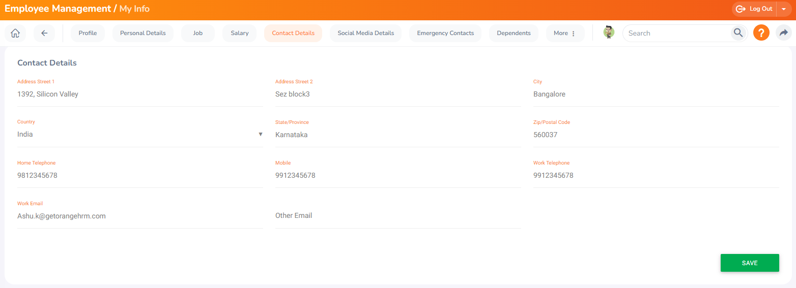

Figure 1.1.3

# 1.1.4 Emergency Contact

To input emergency contact details, select "Emergency Contacts" in the "Personal" column and the screen shown in Figure 1.1.4.1 will appear.

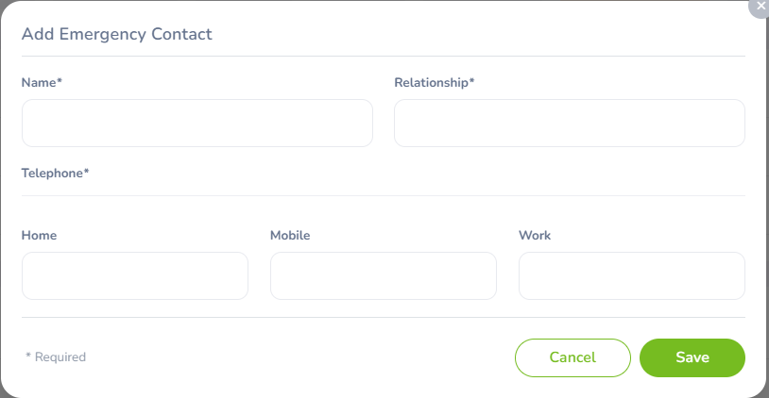

Figure 1.1.4.1

Enter the "Name" of the person to be contacted in case of emergency, specify your "Relationship" with them, and provide a "Home Telephone" or "Mobile Number" where the company can reach them. Click "Save" to add the details and the emergency contact will be listed as depicted in Figure 1.1.4.2

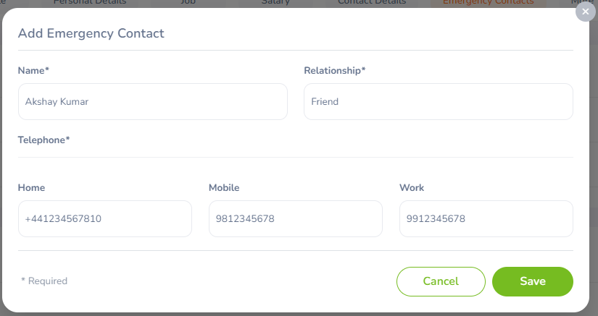

Figure 1.1.4.2

You can add multiple entries for emergency contacts. To delete an entry, check the box next to the specific entry. Deleting multiple entries simultaneously is possible by selecting the checkboxes of entries you wish to delete and clicking "Delete." As depicted in Figure 1.1.4.3

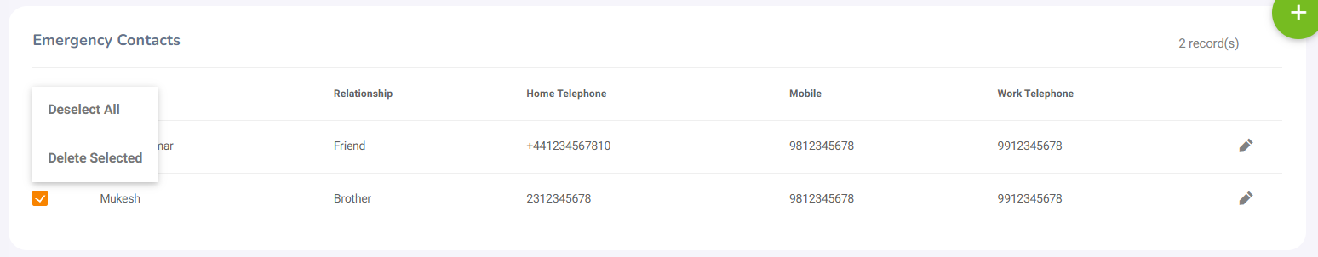

Figure 1.1.4.3

Additionally, you can upload supporting attachments by clicking "Add" under "Attachment." Choose a file from the relevant path and upload it by clicking "Browse." Then select the file and click on “Open”. As depicted in Figure 1.1.4.4. Then click on “Save”

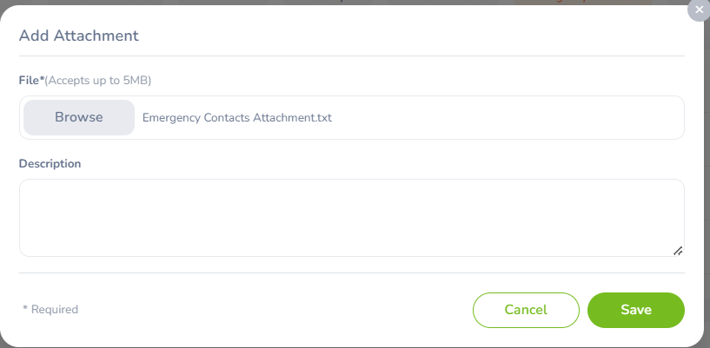

Figure 1.1.4.4

# 1.1.5 Dependents

If you have dependents, you can record their details here. To add a dependent, select "Dependents" under the "Personal" column, and the screen depicted in Figure 1.1.5.1 will appear.

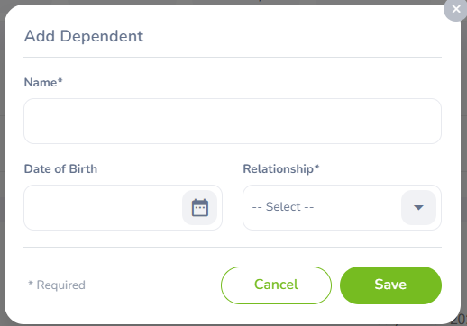

Figure 1.1.5.1

Enter the "Name" of your dependent, specify the "Relationship," and provide their "Date of Birth."

Click "Save" after entering the required fields, and your dependent will be listed as shown in Figure 1.1.5.2

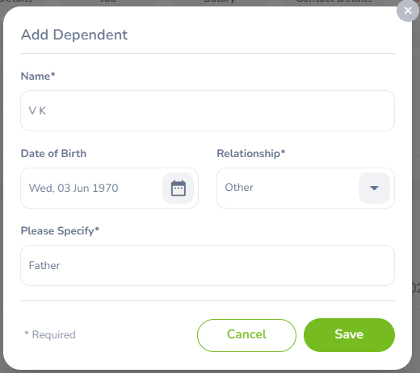

Figure 1.1.5.2

You can add multiple entries for dependents. To delete an entry, check the box next to the specific entry. Deleting multiple entries simultaneously is possible by selecting the checkboxes of entries you wish to delete and clicking "Delete." As depicted in Figure 1.1.5.3

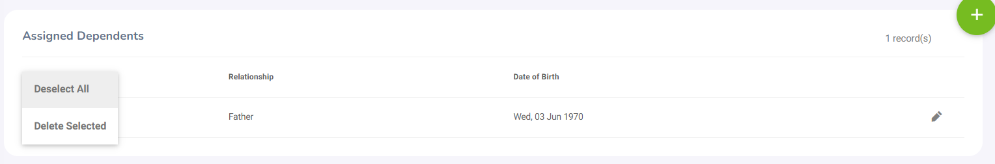

Figure 1.1.5.3

Additionally, you can upload supporting attachments by clicking "Add" under "Attachment." Choose a file from the relevant path and upload it by clicking "Browse." Then select the file and click on “Open”. As depicted in Figure 1.1.5.4. Then click on “Save”

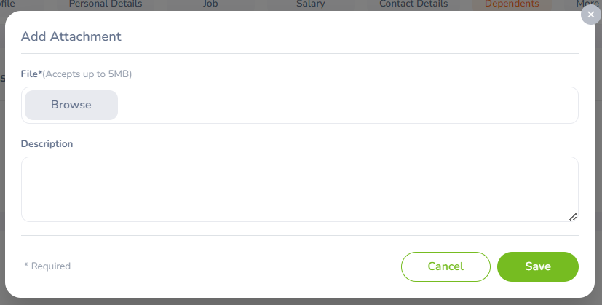

Figure 1.1.5.4

# 1.1.6 Immigration

You can input your immigration information here. To add immigration details, choose "Immigration" under the "Personal" column, and the screen displayed in Figure 1.1.6.1 will appear.

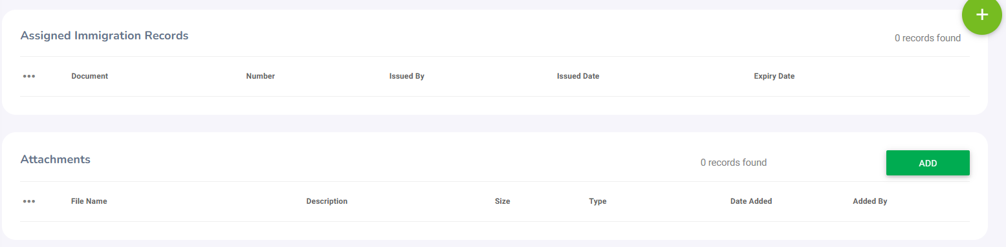

Figure 1.1.6.1

Select the document type (Passport or Visa), enter the "Number" (passport or visa number), specify the "Issued Date," "Expiry Date," the "Eligible Status" of your Passport/Visa, and the "Eligible Review Date" indicating when the eligibility status was last reviewed. If necessary, you may add a comment. Click "Save" after adding the required fields, and the immigration documents will be listed as depicted in Figure 1.1.6.2

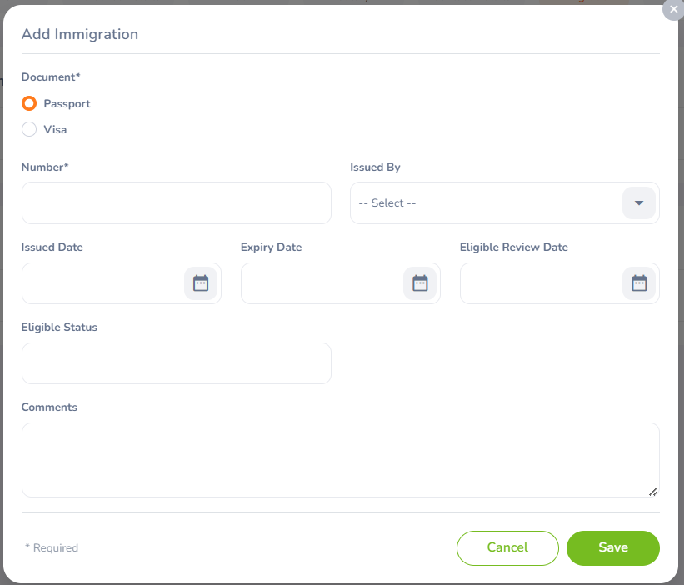

Figure 1.1.6.2

Multiple entries of immigration documents can be added. To delete an entry, check the box next to the specific entry. Deleting multiple entries simultaneously is possible by selecting the checkboxes of entries you wish to delete and clicking "Delete." As depicted in Figure 1.1.6.3

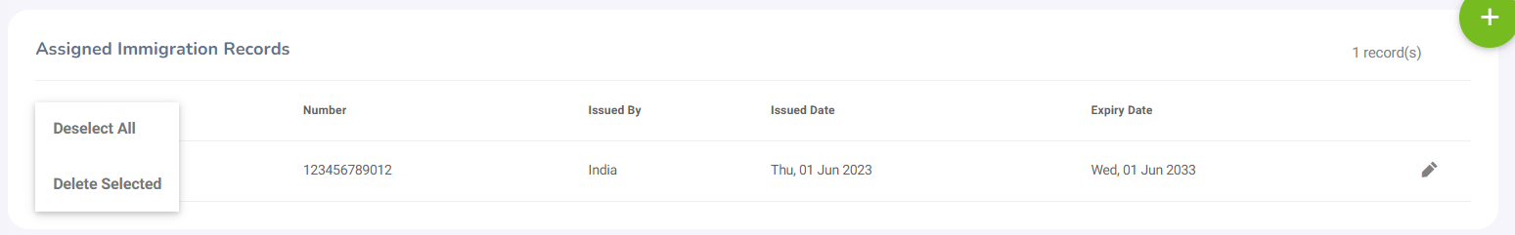

Figure 1.1.6.3

Additionally, you can upload supporting attachments by clicking "Add" under "Attachment." Choose a file from the relevant path and upload it by clicking "Browse." Then select the file and click on “Open”. As depicted in Figure 1.1.6.4. Then click on “Save”

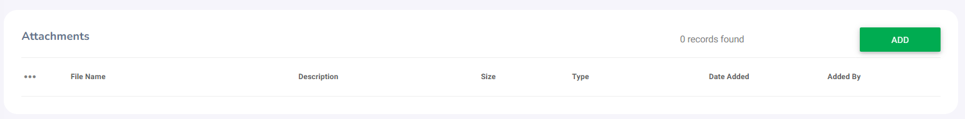

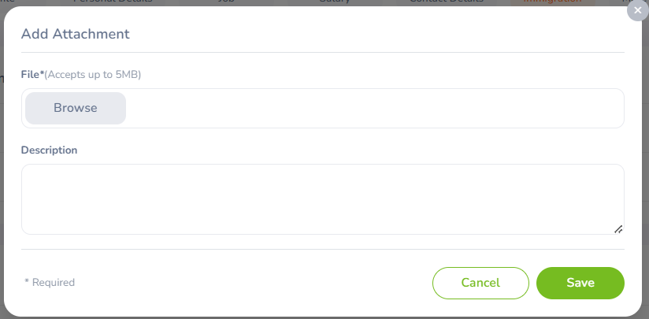

Figure 1.1.6.4

# 1.1.7 Job

The ESS-User is unable to modify job details and can only view pre-defined job details set by the administrator, illustrated in Figure 1.1.7.1 , 1.1.7.2 and 1.1.7.3. Editing is restricted for the following fields:

* Job Title
* Job Specification
* Employment Status
* Job Category
* Joined Date
* Sub Unit
* Location
* Employment Contract Start Date
* Employment Contract End Date
* Attachments

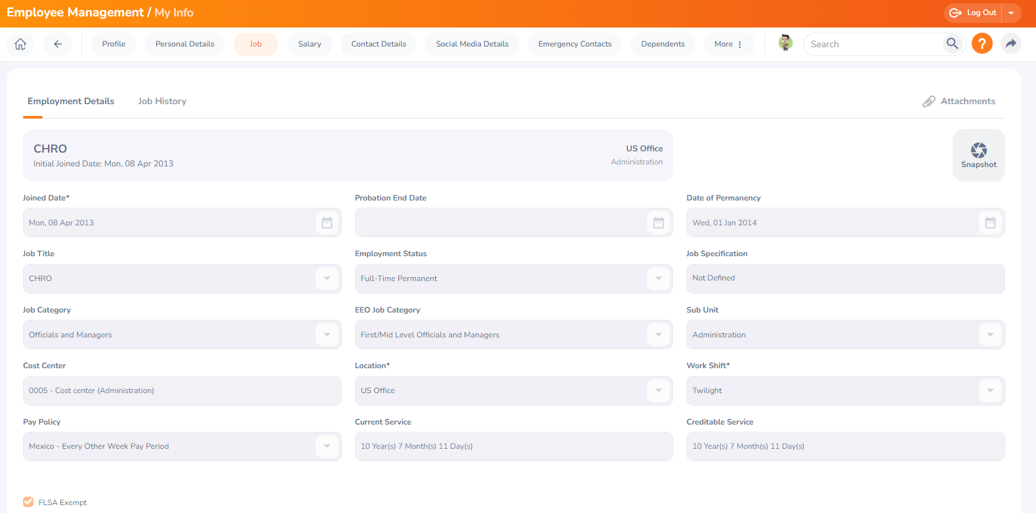

Figure 1.1.7.1

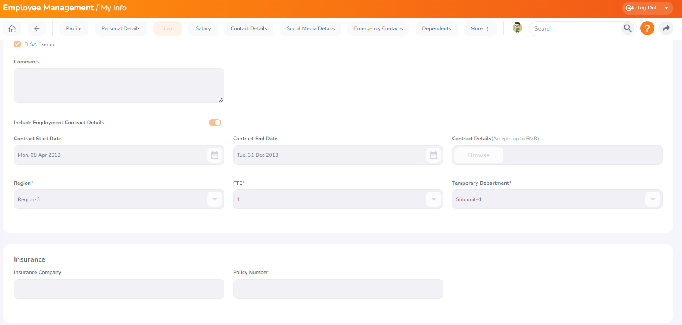

Figure 1.1.7.2

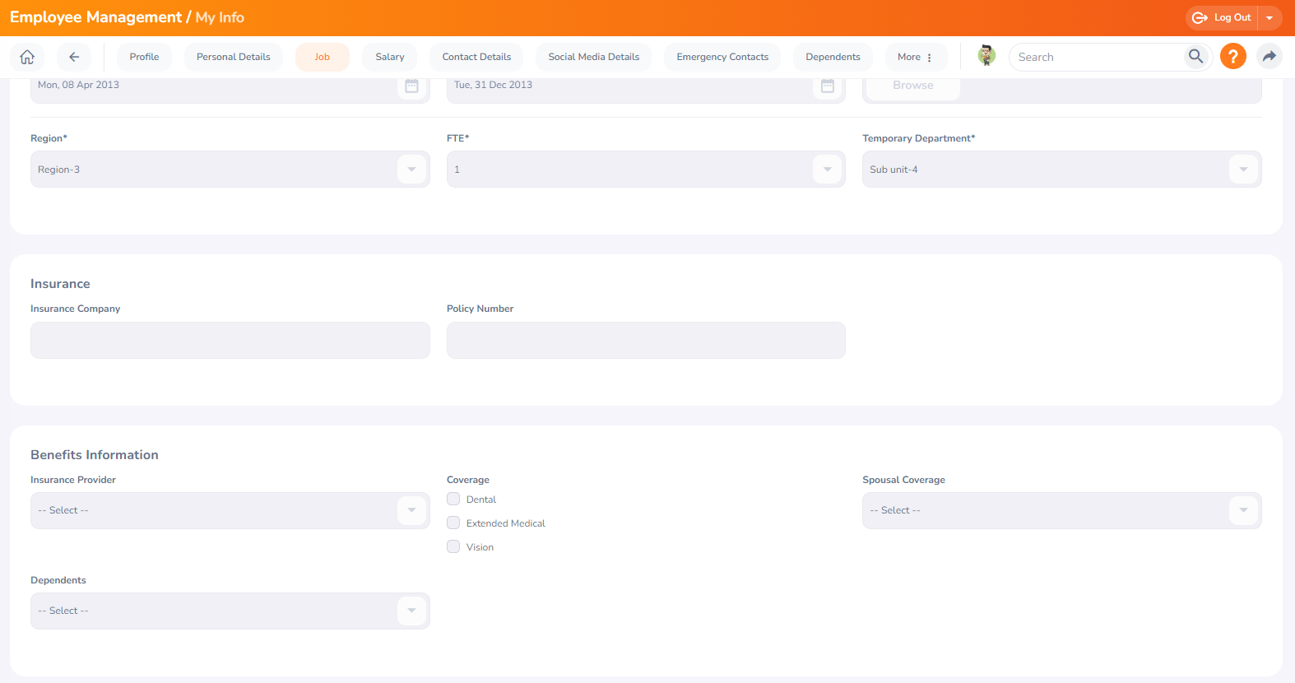

Figure 1.1.7.3

# 1.1.8 Salary

The salary information field is entirely concealed from the ESS-User, as depicted in Figure 1.1.8.1 and Figure 1.1.8.2 Only the HR Admin possesses access to this information and must manually communicate it to the ESS-User. Editing is restricted for the following fields:

* Salary
* Salary Component
* Pay Frequency
* Currency
* Amount
* Comments
* Direct Deposit Details
* Attachments

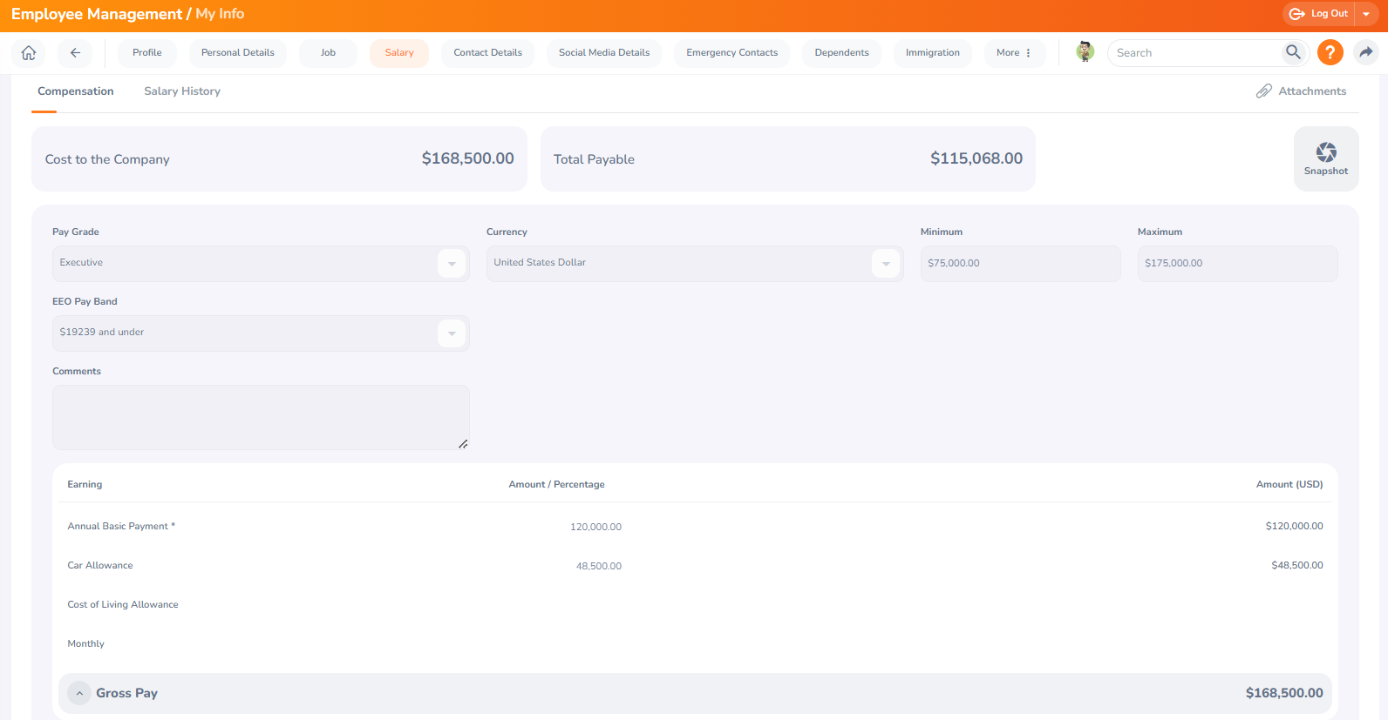

Figure 1.1.8.1

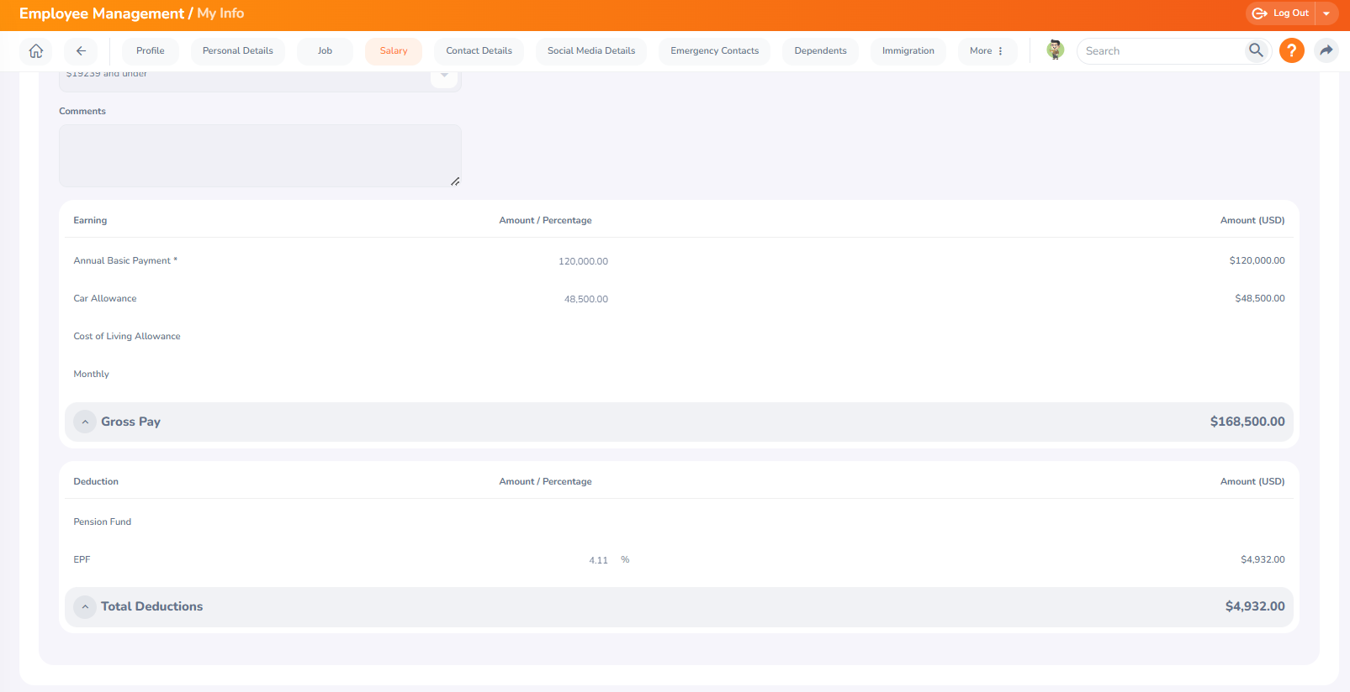

Figure 1.1.8.2

# 1.1.9 Report To

As an ESS-User, you can only view the list of supervisors to whom you report. If you also hold the role of an ESS-Supervisor, you will see the list of your subordinates, as illustrated in Figure 1.1.9.1 Editing is restricted for the following fields:

* Assigned Supervisors
* Assigned Subordinates
* Attachments

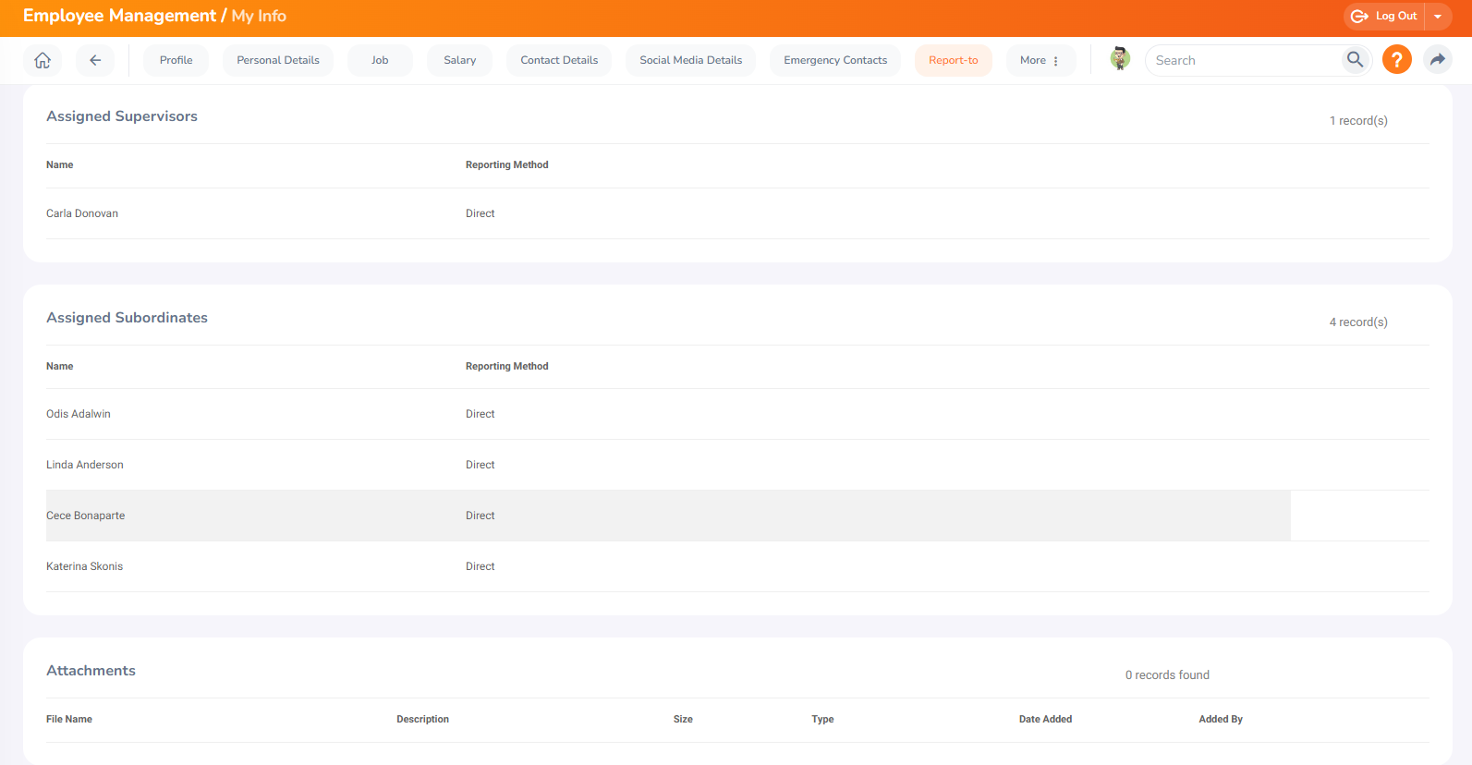

Figure 1.1.9.1

**1.1.10 Qualifications**

Previous work experiences can be recorded here. To input past work experiences, click "Add" under "Work Experience," and the screen depicted in Figure 1.1.10.1and 1.1.10.2 will appear.

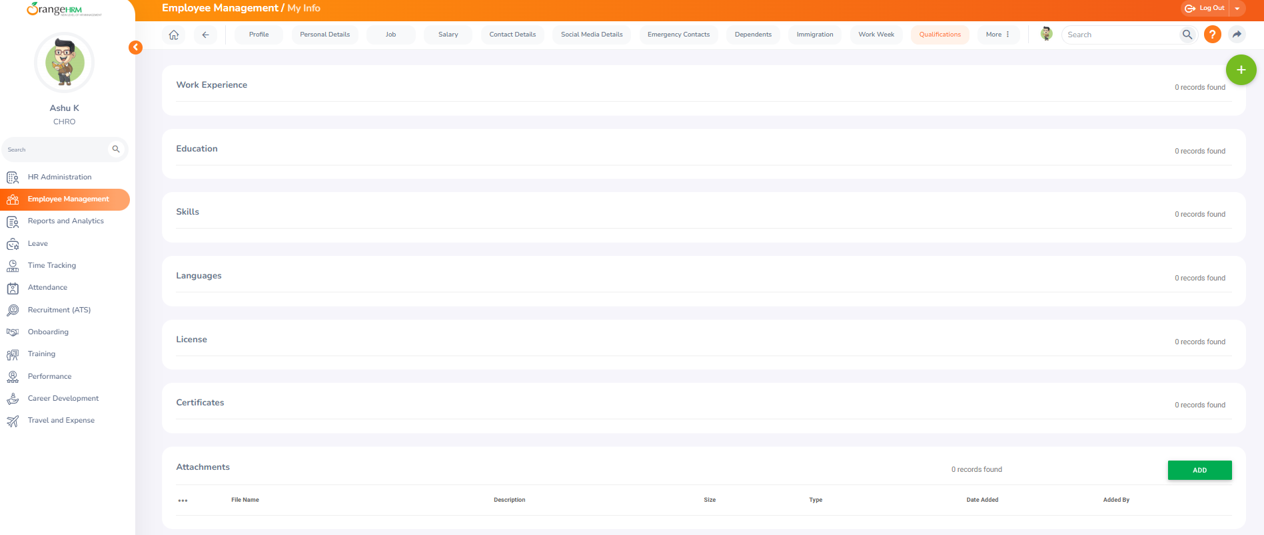

Figure 1.1.10.1

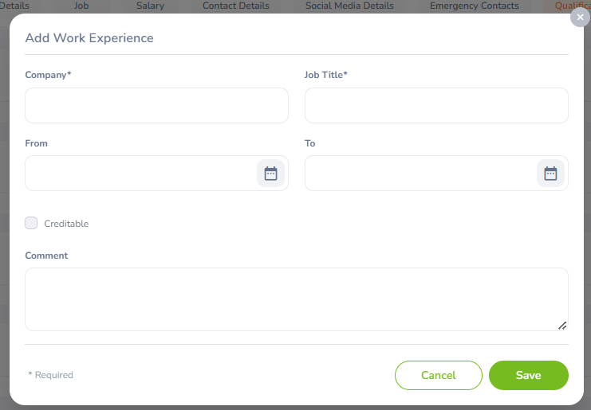

Figure 1.1.10.2